- Lab Report 1
- Dietmar Steiner
- L00131070)

Exercise 1:
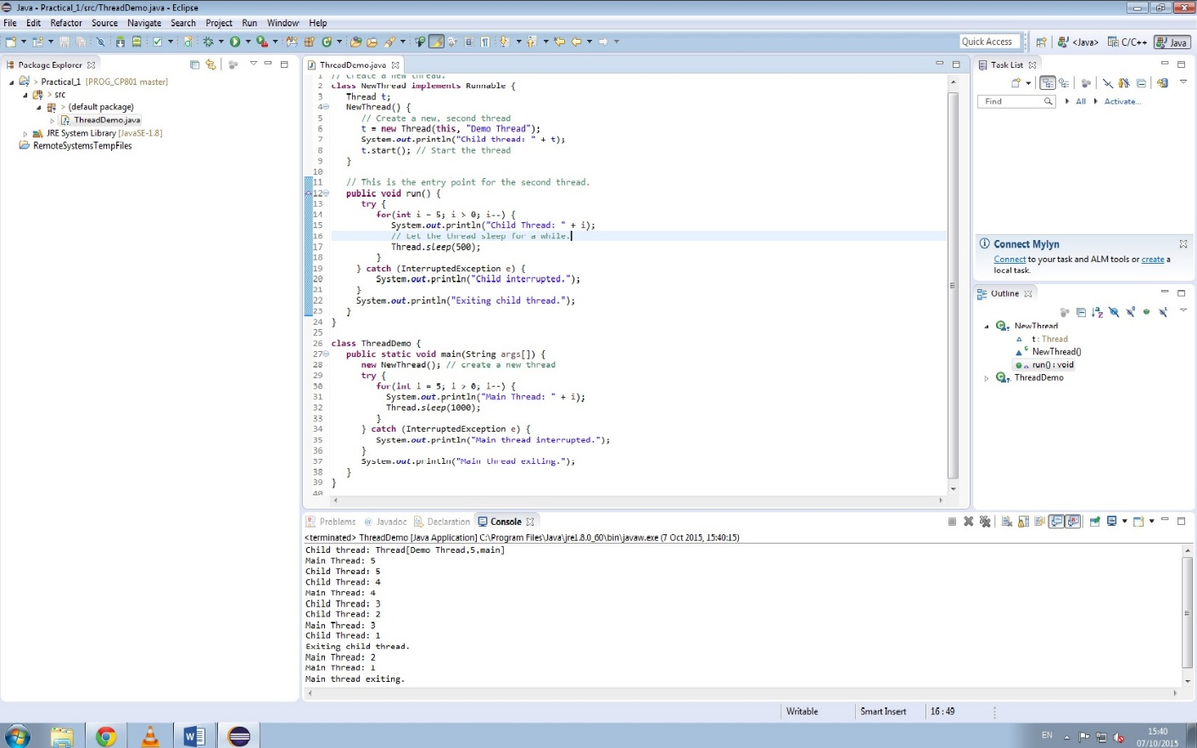
In this exercise the class NewThread is created by implementing the Runable Interface.

Exercise 2:
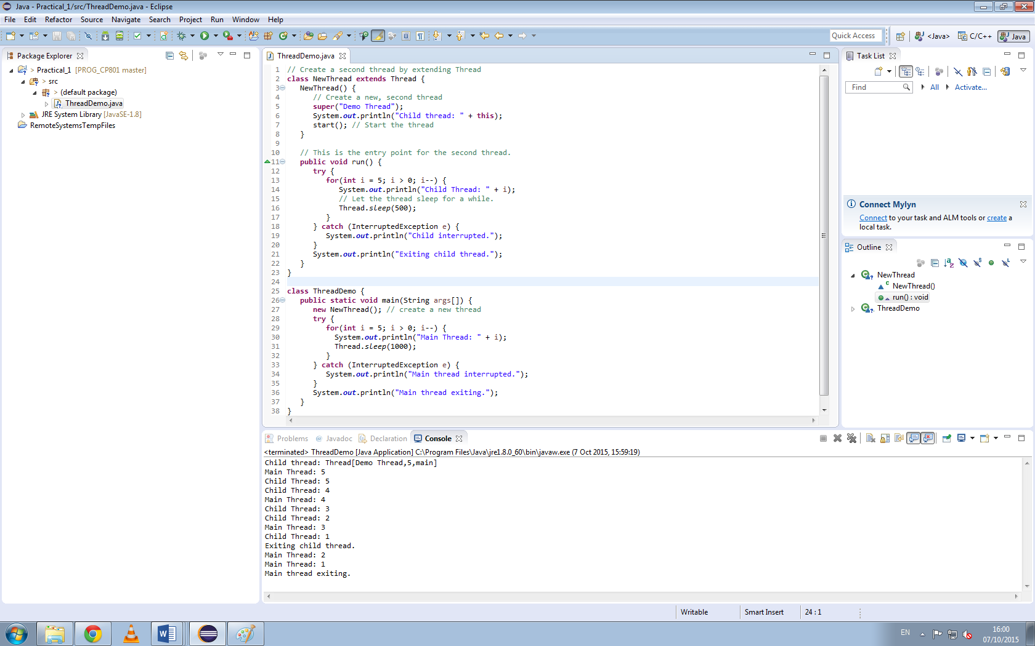
In this exercise the class NewThread is created by extending the Thread class and overriding the run() method .

Questions:
The new output is as follows:
Child thread: Thread[Demo Thread,5,main]
Main Thread: 5
Child Thread: 5
Child Thread: 4
Main Thread: 4
Child Thread: 3
Child Thread: 2
Main Thread: 3
Child Thread: 1
Exiting child thread.
Main Thread: 2
Main Thread: 1
Main thread exiting.
public void start():
This method starts the thread by invoking run().
public void run():
This method is executed when the thread is started. The thread is stopped, when the run() method returns.

public final void setName(String name):
This method sets the name variable in the class Thread.
public final void setPriority(int priority):
This method set the priority for this thread.
The smaller of the given priority or the max thread’s group priority is set as the priority.
public final void setDaemon(boolean on):
Marks this thread as a deamon thread or user thread.
public final void join(long millisec):
Waits for this thread to finish for the given time in milliseconds.
public void interrupt():
Sets the interrupt flag of the thread, if the thread is not in a blocked state.
If the thread is blocked by wait, join or sleep, an InteruptedException is thrown and the interrupt flag will not be set.
If the thread is blocked by a Selector the interrupted flag is set and the thread continuous execution.
If the thread is blocked by an interruptible I/O operation, an ClosedByInteruptException is thrown.
public final boolean isAlive()
Return true when the thread is running and has not yet ended.

Conclusion
There is no real difference between the two methods of creating a thread as the behaviour is the same. Nonetheless the runnable implementation is preferred as it uses the interface inheritance, so the class inheritance can still be used.

